Static IP Assignment for StatefulSet Pods using Multus CNI on Kubernetes
Goal: Assign stable IPs to pods (web-0, web-1, web-2) in a StatefulSet without EKS, using Multus + a controller.
- Prerequisites
- Kubernetes cluster running on EC2 (3 nodes in your case).
- kubectl configured.
- Calico installed as primary CNI.
- Multus installed for secondary network support.
- Python (3.10) image available for controller.

- Create Namespace
kubectl create namespace statefulset-demo

- Create Service Account and RBAC
File: rbac.yaml
apiVersion: v1
kind: ServiceAccount
metadata:
name: static-ip-controller
namespace: statefulset-demo
---
apiVersion: rbac.authorization.k8s.io/v1
kind: Role
metadata:
name: static-ip-controller
namespace: statefulset-demo
rules:
- apiGroups: [""]
resources: ["pods"]
verbs: ["get", "list", "watch", "patch", "delete"]
---
apiVersion: rbac.authorization.k8s.io/v1
kind: RoleBinding
metadata:
name: static-ip-controller
namespace: statefulset-demo
subjects:
- kind: ServiceAccount
name: static-ip-controller
roleRef:
kind: Role
name: static-ip-controller
apiGroup: rbac.authorization.k8s.io
Apply:
kubectl apply -f rbac.yaml

- Create NetworkAttachmentDefinitions (Multus)
Each pod will have a dedicated network.
Example: net-attach.yaml
apiVersion: k8s.cni.cncf.io/v1
kind: NetworkAttachmentDefinition
metadata:
name: web-0-network
namespace: statefulset-demo
spec:
config: '{
"cniVersion": "0.3.1",
"type": "bridge",
"bridge": "br-web0",
"ipam": {
"type": "static",
"addresses": [
{
"address": "192.168.126.6/32",
"gateway": "192.168.126.1"
}
]
}
}'
---
apiVersion: k8s.cni.cncf.io/v1
kind: NetworkAttachmentDefinition
metadata:
name: web-1-network
namespace: statefulset-demo
spec:
config: '{
"cniVersion": "0.3.1",
"type": "bridge",
"bridge": "br-web1",
"ipam": {
"type": "static",
"addresses": [
{
"address": "192.168.126.7/32",
"gateway": "192.168.126.1"
}
]
}
}'
---
apiVersion: k8s.cni.cncf.io/v1
kind: NetworkAttachmentDefinition
metadata:
name: web-2-network
namespace: statefulset-demo
spec:
config: '{
"cniVersion": "0.3.1",
"type": "bridge",
"bridge": "br-web2",
"ipam": {
"type": "static",
"addresses": [
{
"address": "192.168.126.8/32",
"gateway": "192.168.126.1"
}
]
}
}'
Apply:
kubectl apply -f net-attach.yaml
Check:
kubectl get network-attachment-definitions.k8s.cni.cncf.io -n statefulset-demo

- Create Static IP Controller
The controller watches pods and applies Multus network annotations automatically.
File: controller.yaml
apiVersion: v1
kind: ConfigMap
metadata:
name: static-ip-controller
namespace: statefulset-demo
data:
controller.py: |
from kubernetes import client, config, watch

config.load_incluster_config()
v1 = client.CoreV1Api()
w = watch.Watch()

for event in w.stream(v1.list_namespaced_pod, namespace="statefulset-demo"):
pod = event["object"]
name = pod.metadata.name

if not name.startswith("web-"):
continue

annotations = pod.metadata.annotations or {}

if annotations.get("static-ip-assigned") == "true":
continue

network = f"{name}-network"

patch = {
"metadata": {
"annotations": {
"k8s.v1.cni.cncf.io/networks": network,
"static-ip-assigned": "true"
}
}
}

v1.patch_namespaced_pod(name, "statefulset-demo", patch)
v1.delete_namespaced_pod(name, "statefulset-demo")

---
apiVersion: apps/v1
kind: Deployment
metadata:
name: static-ip-controller
namespace: statefulset-demo
spec:
replicas: 1
selector:
matchLabels:
app: static-ip-controller
template:
metadata:
labels:
app: static-ip-controller
spec:
serviceAccountName: static-ip-controller
containers:
- name: controller
image: python:3.10
command: ["sh", "-c"]
args:
- pip install kubernetes && python /app/controller.py
volumeMounts:
- name: code
mountPath: /app
volumes:
- name: code
configMap:
name: static-ip-controller
Apply:
kubectl apply -f controller.yaml
Check logs:
kubectl logs -f deployment/static-ip-controller -n statefulset-demo

- Create StatefulSet
File: statefulset.yaml
apiVersion: apps/v1
kind: StatefulSet
metadata:
name: web
namespace: statefulset-demo
spec:
serviceName: "web"
replicas: 3
selector:
matchLabels:
app: web
template:
metadata:
labels:
app: web
spec:
containers:
- name: nginx
image: nginx:stable
ports:
- containerPort: 80
Apply:
kubectl apply -f statefulset.yaml

- Verify
Check pods:
kubectl get pods -n statefulset-demo -o wide
Describe pod for annotations and events:
kubectl describe pod web-0 -n statefulset-demo
Check for:
- k8s.v1.cni.cncf.io/networks annotation
- Multus event: AddedInterface eth0 [192.168.126.x/32]
- Pod is Ready
Check pod IPs:
kubectl exec -it web-0 -n statefulset-demo -- ip addr

Outcome
- Each pod (web-0, web-1, web-2) has a stable static IP.
- Multus manages secondary network.
- Controller ensures auto-healing and IP assignment on pod recreation.
- Works on plain EC2 Kubernetes (no EKS).

IMPLEMENTATION SCREENSHOTS
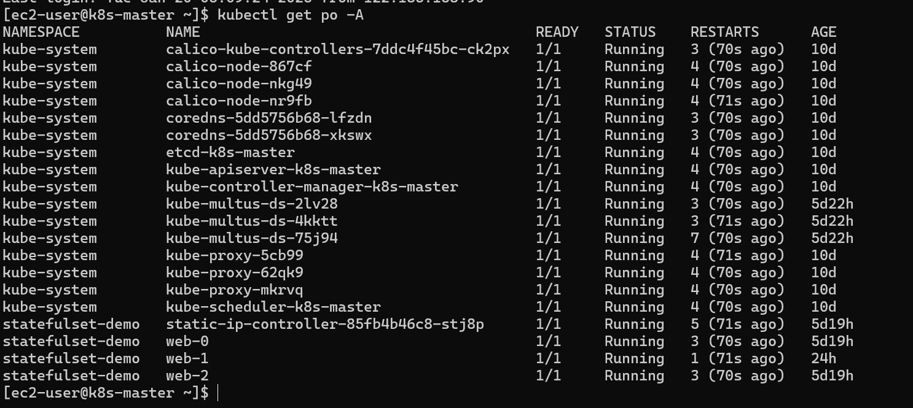

Before deletion of pods
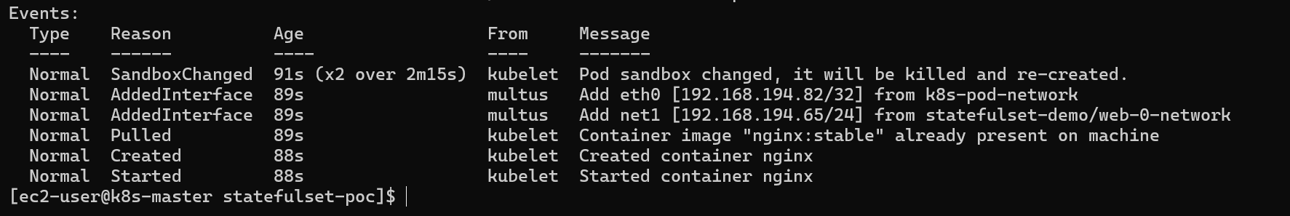
After restarting
